LAB 14
Task 1:
Code:
#include<iostream>
#include<stack>
using namespace std;

struct Node {
char ch;
Node* next;
Node() : next(nullptr) {}
};

class Graph {
Node** users;
int size;
int capacity = 0;

public:
Graph(int size) {
this->size = size;
users = new Node*[size];
for (int i = 0; i < size; i++) {
users[i] = nullptr;
}
}

void insert(char c) {
if (capacity != size) {
Node* user = new Node;
user->ch = c;
users[capacity++] = user;
}
else {
cout << "Graph is full. Cannot insert more users.\n";
}
}

void add(char src, char des) {
for (int i = 0; i < size; i++) {
if (users[i] && users[i]->ch == src) {
Node* user = new Node;
user->ch = des;
user->next = users[i]->next;
users[i]->next = user;
return;
}
}
cout << "Source user not found.\n";
}

void find(char user1, char user2) {
Node* friends1 = nullptr;
Node* friends2 = nullptr;
for (int i = 0; i < size; i++) {
if (users[i] && users[i]->ch == user1) {
friends1 = users[i]->next;
}
if (users[i] && users[i]->ch == user2) {
friends2 = users[i]->next;
}
}

if (!friends1 || !friends2) {
cout << "One or both users not found!\n";
return;
}

cout << "Mutual friends between " << user1 << " and " << user2 << ": ";
Node* temp1 = friends1;
while (temp1) {
Node* temp2 = friends2;
while (temp2) {
if (temp1->ch == temp2->ch) {
cout << temp1->ch << " ";
}
temp2 = temp2->next;
}
temp1 = temp1->next;
}
cout << endl;
}
int index(char c)
{
Node* current=nullptr;
for (int i = 0; i < size; i++)
{
current = users[i];
if (c == current->ch)
{
return i;
}
}
}

void DFS(char src)
{
bool cycleDetected = false;
int srcc = index(src);
if (srcc >= 0 && srcc < size)
{
stack<int> s;
bool* visited = new bool[size];
bool* inStack = new bool[size];

for (int i = 0; i < size; i++)
{
visited[i] = false;
inStack[i] = false;
}

s.push(srcc);
inStack[srcc] = true;

while (!s.empty())
{
int current = s.top();
s.pop();

if (!visited[current])
{
visited[current] = true;
Node* temp = users[current]->next;
while (temp)
{
int friendIndex = index(temp->ch);
if (friendIndex != -1)
{
if (!visited[friendIndex])
{
s.push(friendIndex);
inStack[friendIndex] = true;
}
else
{
cycleDetected = true;
break;
}
}
temp = temp->next;
}
}

inStack[current] = false;
}

if (cycleDetected)
{
cout << "\nCycle detected!\n";
}
else
{
cout << "\nNo cycle detected.\n";
}

delete[] visited;
delete[] inStack;
}
}

~Graph() {
Node* current = nullptr;
for (int i = 0; i < size; i++) {
current = users[i];
while (current) {
Node* temp = current;
current = current->next;
delete temp;
}
}
delete[] users;
}
};

int main() {
Graph graph(10);
int choice;
char user, friend1, friend2, dfsUser;

do {
cout << "\nMenu:\n";
cout << "1. Add user\n";
cout << "2. Add friendship\n";
cout << "3. Find mutual friends\n";
cout << "4. Perform DFS and Detect Cycle\n";
cout << "5. Exit\n";
cout << "Enter your choice: ";
cin >> choice;

switch (choice) {
case 1:
cout << "Enter user character: ";
cin >> user;
graph.insert(user);
break;

case 2:
cout << "Enter source user: ";
cin >> friend1;
cout << "Enter destination user (friend): ";
cin >> friend2;
graph.add(friend1, friend2);
break;

case 3:
cout << "Enter first user: ";
cin >> friend1;
cout << "Enter second user: ";
cin >> friend2;
graph.find(friend1, friend2);
break;

case 4:
cout << "Enter the user to start DFS from: ";
cin >> dfsUser;
graph.DFS(dfsUser);
break;

case 5:
cout << "Exiting program...\n";
break;

default:
cout << "Invalid choice! Please try again.\n";
}
} while (choice != 5);

return 0;
}
Output:
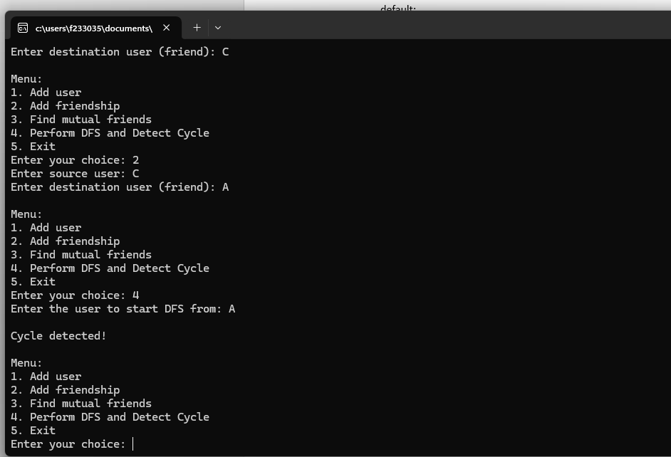
Task 3:
Code:

#include <iostream>
#include <string>
#include <list>
using namespace std;

const int TABLE_SIZE = 8;

// Hash Table class with Open Chaining (Linked List)
class HashTable {
list<string> table[TABLE_SIZE]; // Array of linked lists

public:
// Hash function to map a key to a hash index
int hash(string key) {
int sum = 0;
for (char ch : key) {
sum += ch; // Sum of ASCII values of characters
}
return sum % TABLE_SIZE; // Hash key within table size range
}

// Function to insert a string into the hash table (Open Chaining)
void insert(string key) {
int index = hash(key);
table[index].push_back(key); // Insert into the linked list at the hashed index
}

// Function to search for a key in the hash table
bool search(string key) {
int index = hash(key);
for (const string& str : table[index]) {
if (str == key) {
return true; // Found the key
}
}
return false; // Key not found
}

// Function to display the hash table with linked lists
void display() {
cout << "\nHash Table Display (with Open Chaining):\n";
for (int i = 0; i < TABLE_SIZE; i++) {
cout << "[" << i << "]";
if (table[i].empty()) {
cout << " -> (empty)";
}
else {
for (const string& key : table[i]) {
cout << " -> " << key;
}
}
cout << endl;
}
}

// Linear Probing for collision handling
void linearProbingInsert(string key) {
int index = hash(key);
int startIndex = index;

while (!table[index].empty()) {
index = (index + 1) % TABLE_SIZE;
if (index == startIndex) {
cout << "Hash table is full. Unable to insert " << key << endl;
return;
}
}
table[index].push_back(key);
}

// Quadratic Probing for collision handling
void quadraticProbingInsert(string key) {
int index = hash(key);
int i = 1;

while (!table[index].empty()) {
index = (index + i * i) % TABLE_SIZE; // Quadratic probing
i++;
if (i == TABLE_SIZE) {
cout << "Hash table is full. Unable to insert " << key << endl;
return;
}
}
table[index].push_back(key);
}
};

// Function to display menu
void displayMenu() {
cout << "\nHash Table Operations Menu:\n";
cout << "1. Insert Name (Open Chaining)\n";
cout << "2. Search for Name\n";
cout << "3. Display Hash Table\n";
cout << "4. Insert Name using Linear Probing\n";
cout << "5. Insert Name using Quadratic Probing\n";
cout << "6. Exit\n";
}

// Function to handle user input and call corresponding operations
void handleUserInput(HashTable& ht) {
int choice;
string name;

do {
displayMenu();
cout << "Enter your choice: ";
cin >> choice;

switch (choice) {
case 1:
cout << "Enter name to insert: ";
cin >> name;
ht.insert(name);
break;
case 2:
cout << "Enter name to search: ";
cin >> name;
if (ht.search(name)) {
cout << name << " found in the hash table.\n";
}
else {
cout << name << " not found in the hash table.\n";
}
break;
case 3:
cout << "\nDisplaying the hash table:\n";
ht.display();
break;
case 4:
cout << "Enter name to insert using Linear Probing: ";
cin >> name;
ht.linearProbingInsert(name);
break;
case 5:
cout << "Enter name to insert using Quadratic Probing: ";
cin >> name;
ht.quadraticProbingInsert(name);
break;
case 6:
cout << "Exiting the program.\n";
break;
default:
cout << "Invalid choice! Please try again.\n";
}
} while (choice != 6);
}

int main() {
HashTable ht;
handleUserInput(ht);
system("pause");
}
Output:
